**SOUQ-UL-TIB**



**BS (SE) FYP 1 Report**

**Submitted By:**

**Rizwana M. Younus 2015/comp/BS (SE)/18673 1518543**

**Sania Shoaib 2015/comp/ BS (SE)/18679 1518549**

**Shaista Kanwal 2015/comp/ BS (SE)/18682 1518555**

**Kiran Pervaiz 2015/comp/ BS (SE) /18655 1518525**

**9th July, 2018**

**Department of Computer Science and information technology**

**Jinnah University for Women**

**5-C NAZIMABAD, KARACHI 74600**

# Abstract

People face several types of problems related to medicine’s purchasing system in daily life routines. Like many peoples are unable to go outside to purchase their regular basis medicines because of different type of issues. Through this application we are proposing an application Souq-ul-Tib, (an online medicine buying application). Throughout the application, we will describe the proposed design, structure, features and operational ways of our android application. We also explain our 3 major features of application Pill reminder, OCR technique, Drug Information.

The aim of Souq-Ul-Tib is that the people can buy online medicines along with the facilities of pills reminder, drugs information. The main objective of this application is to provide facility to purchase online medicine. It can also provide you the easiest way to lookup drug information and description with different diseases, affects, side effects and many more.

# Table of Content

SOUQ-UL-TIB 1

ACKNOWLEDGEMENT 6

Chapter 1 8

SOFTWARE REQUIREMENT SPECIFICATION 8

1.1 Purpose 8

1.2 Product Scope 8

1.3 Overall Description 9

1.3.1 product Perspective 9

1.3.2 Product Function 9

1.3.3 User characteristics 9

1.3.4 Operating environment 10

1.3.5 Constraints 10

1.3.6 User documentation 10

1.3.7 Assumptions and dependencies 10

1.4 System features: 10

1. 5 Other non-functional requirements: 11

1.1.1 Performance requirements: 11

1.1.2 Safety requirements: 11

1.1.3 Security requirements: 11

ANALYSIS AND DESIGN 12

2.1 DATA FLOW DIAGRAM 12

2.2 ENTITY RELATIONSHIP DIAGRAM 13

2.3 USECASE DIAGRAM 14

2.4 ACTIVITY DIAGRAM 15

2.5 DEPLOYMENT DIAGRAM 16

2.6 CLASS DIAGRAM 17

Chapter 3 19

TOOLS AND TECHNOLOGIES 19

3.1 SOFTWARE 19

3.1.1 MICROSOFT VISUAL STUDIO 2015 19

3.1.2 MICROSOFT SQL SERVER MANAGEMENT STUDIO 19

3.1.3 ASP.NET 19

3.1.4 ANDROID STUDIO 20

3.1.5 Web services (restful api) 20

Chapter 4 21

User interface design 21

4.1 Mobile Interface Design 21

4.1.1 Main Screen 21

4.1.2 Login 22

4.1.3 Pills reminder 23

4.2 Hardware interface 25

4.3 Software interface 25

Chapter 5 26

Implementation 26

5.1 DATABASE DESIGN 26

5.1.1 Entity 26

5.2 WEB SEVICES 27

5.2.1 Restful Services of Generic Name 27

5.2.2 Restful Services of Manufacture 27

5.2.3 Restful Services of Medicine 27

5.2.5 Restful Services of User 27

Chapter 6 29

System testing 29

6.1 Test plan 29

6.1.1 Mobile application testing 29

6.1.2 Test objective 29

6.2 Functional testing 29

6.3 System Testing 30

6.3.1 PURPOSE 30

6.3.2 TESTERS 30

6.3.3 METHOD 30

6.4 TEST CASE 30

APPENDIX A 32

Glossary 32

Conclusion 33

References 34

# List of Figure

**List of Tables**

Table 6.5 Test Cases 36

Table A.1 Glossary 38

# ACKNOWLEDGEMENT

We are greatly indebted to our parents, without their endless financial, moral support, patience and prayers we can’t do anything. We would like to pay our humble gratitude to our beloved project advisor / internal Miss Tehreem Qamar, her encouragement was the main source and strength to stimulate us to carry this project. We are also grateful to all faculty members of our university JINNAH UNIVERSITY FOR WOMEN for the facilities provided to us. Without them we would have never been able to run our extensive computational analysis.

# Chapter 1

*Chapter 1: Software Requirement Specification*

**SOFTWARE REQUIREMENT SPECIFICATION**

## Purpose

The main purpose of the application Souq-ul-Tib is to provide medicines to the people at their home. In this application people can buy online medicines also set pills taken timing by pills reminder feature, can able to view drugs info through OCR these all features are provided in one app.

## Product Scope

The main scope of our application is to facilitate users by buying online medicines. There are 2 type of users, the user of the application or you can say customer and the admin.

* From Customer side, In order to purchase medicines you first have to create your account and login application if account is already exists.
* In this application you have the following features, you can do online ordering of medicines and healthcare product.
* We are providing you two ways of ordering medicines (Everyday medicines and prescription based medicines). There is a condition applied on prescription based medicines that you can’t place order unless you upload your prescription from your consultant physician.
* For making order add your entire product that you want to purchase into cart then, it will show a net amount that you have to pay.
* The application will also facilitate you by multiple payment option like: PayPal, visa card, credit card and cash on delivery. You have to fulfill all requirements for making payment.
* Another feature of application is that, you will also facilitate yourselves by pills reminders features. In pills reminder you can set your pills taken timing than it will remind you by notification so you will never forget to take medicines.
* We will also facilitate you by drug info service in which you can view your drug details such as age dosage, allergy and affect/side effect with Android OpenCV OCR. In which you can scan your medicine name through your mobile camera and then it will give you all the necessary information of that particular medicine.

*Chapter 1: Software Requirement Specification*

* From Admin side, the admin will able to manage inventory (can able to add, delete and update medicines and healthcare products) and manage ordering records of customer.

## 1.3 Overall Description

### **1.3.1 Product Perspective**

This Application will be used to provide customer with the facility of medicines at their home. The user of the application can also set drugs taken timing by using our Pills reminder feature.

This application can also provide facility to the customer that the user can view drug information like (Generic Name, Medicine Alternative, Uses of the Drug, Side effect of the drug, Dosage, Price).

### **1.3.2 Product Function**

Souq-ul-Tib provides the following functionalities that are as follow:

* Register or login the users account.
* Add, update or delete medicine, medicine type, generic name and manufacture.
* View medicine info through OCR in which the user can the name of medicine and get info back.
* Set pills taken timings by using pills reminder feature.
* Order medicine.
* Add-to-cart medicine.
* Payment on cash delivery or through card.

### **1.3.3** **User Characteristics**

There are two categories of users in this system. The first one is app user, and the second one is admin, the app users are allowed to see the medicine records, medicine details along with drug info, and can also be able to order medicines. The second type of user, the administrator, will be able to set up the system, adds, delete, update medicines record and view the details of the medicines and the authorized app users and their ordered list, and set user authorization level.

**ADMIN**: The system administrator who is given specific permission for managing and controlling the system.

*Chapter 1: Software Requirement Specification*

**APP USER**: Someone who uses the System.

### **1.3.4** **Operating environment**

The Android operating system will be required with the minimum SDK 26.

### **1.3.5** **Constraints**

* The internet connectivity is required for Ordering the medicines.
* Souq-ul-Tib would not provide the internet payment method for E-Commerce.
* If the user’s phone does not support the android operating system then it is a constraint.

### **1.3.6** **User Documentation**

A quick guide is provided to the users at the first time launch of the app provided to them for any problems face by the users.

### **1.3.7** **Assumptions and Dependencies**

* It will provide facility to order medicines and get drug information.
* It will also provide the facility to the user to take medicines on time by using pills reminder feature.
* It will also be able to scan user’s prescription by using their mobile camera.

## 1.4 System Features

Souq-ul-Tib will provides the following features:

* To buy medicines online with its own store along with the medicine alternate.
* It can also get information of drug by searching or by OCR feature.
* Provides the user to set pills taken timings by using pills reminder feature.
* It can also provide facility to the user to pay for medicine according to their wish for example: on cash delivery or through card.

## 1. 5 Other non-functional requirements

*Chapter 1: Software Requirement Specification*

### **Performance Requirements**

In the performance requirement the testers team can validate that all the features of the application work properly or the system is capable, can perform all the features properly.

### **Safety Requirements**

The data handled in the SQL Server is very vital. The server should always be confirmed to run properly and the data are saved to the database at consecutive intervals. Power is a significant feature and the power supply should be always taken care of. An Uninterrupted Power Supply is always recommended.

### **Security Requirements**

Souq-ul-Tib (an e-commerce app) will be password protected. The user will have to enter correct username/email and password in order to access the system. Unauthorized users should not be allowed to access the system so that the integrity and secrecy of each user must be maintained.

**Chapter 2**

*Chapter 2: Analysis and Design*

**ANALYSIS AND DESIGN**

## 2.1 Data Flow Diagram

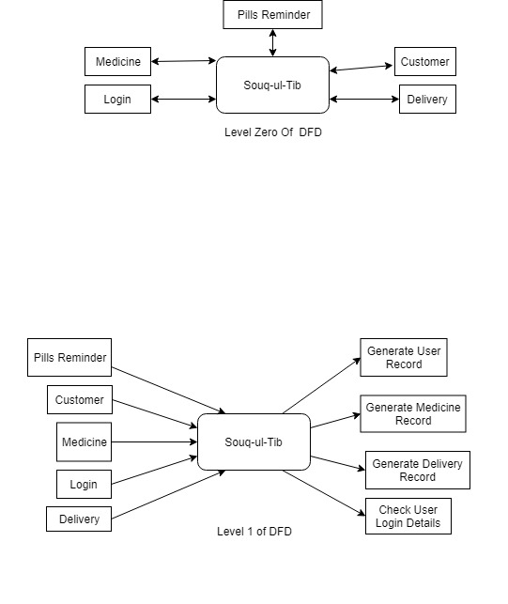The data flow diagram describes the flow of any process or system. In level 0 of DFD Souq-ul-Tib is providing the customer or admin to login to the application, purchase medicines, set pills reminder, and place order.

*Figure 2.1.1: Level 0 DFD*

In level one of DFD it is providing you to generate user record, generate medicine record, generate delivery record and check user login details.



*Figure 2.1.2: Level 1 DFD*

In level 2 of DFD the Admin can login to the system, check medicine availability, check roles of access, and manage modules such as: medicine details, customer details, sells details, stock details, and report and user permission.

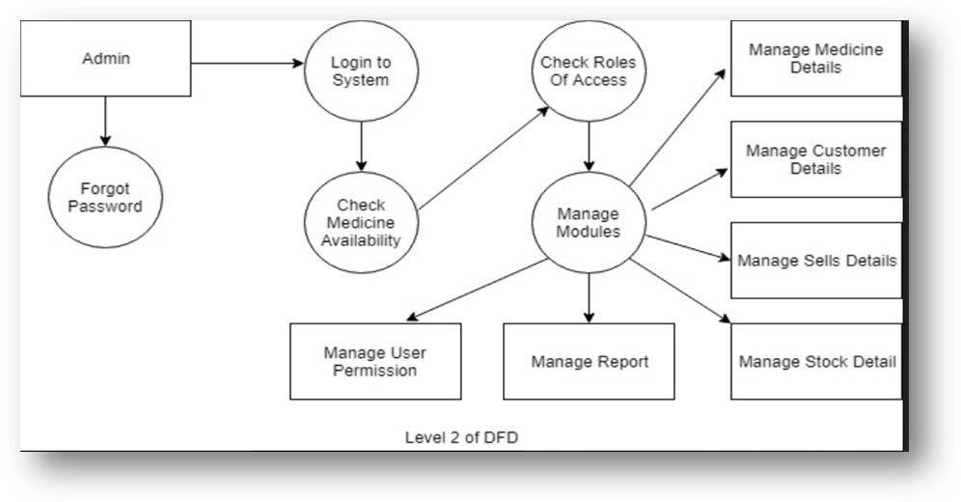

*Figure 2.1.3: Level 2 DFD*

*Chapter 2: Analysis and Design*

## 2.2 ENTITY RELATIONSHIP DIAGRAM

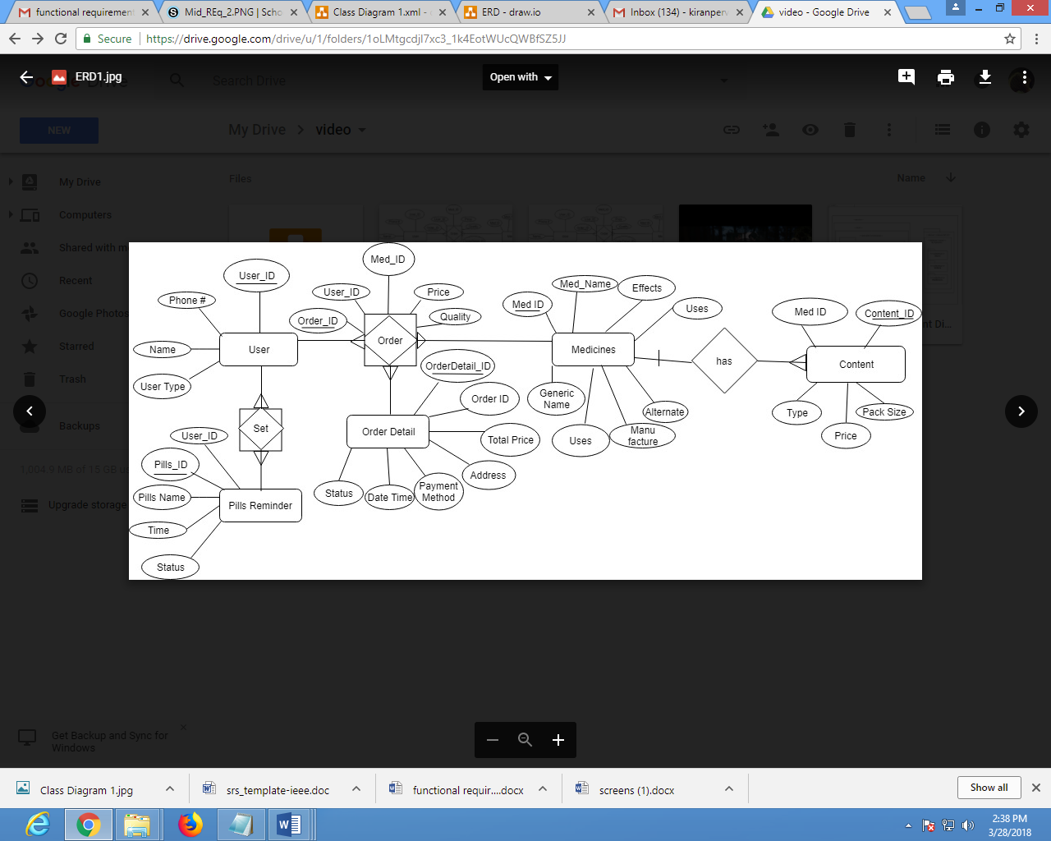An Entity Relationship Diagram (ERD) is also known as Entity Relationship Model. It is a graphical representation of information system that represents the relationship between objects, people, places, events and concepts within the system.The user can set User-id (Primary key), phone number, name and user type. The user can place order by typing Order-id (Primary key), User-id, Med-id, Price and quantity. Order should have order detail like: orderdetail-id (primary key), order-id, total price, address, payment method, date time, status.The order should have all the medicine information like: Med-id (Primary key) , Med-Name, Effects, uses, generic name, dosage, manufacture, alternate. Medicines should have Content details like: Content-id primary key), med-id, pack size, price, type. The user can set pills reminder by: pills_id (primary key), user-id, pills name, time and status.

*Figure 2.2: Level 2 DFD*

## 2.3 USECASE DIAGRAM

*Chapter 2: Analysis and Design*

A use-case diagram describes interactions among the different elements of the system. The Customer can login to the system, get information about medicines, purchase medicines and set pills reminder. The Admin can Login to system, get information about medicines, add new medicine data, update medicine data, delete medicine data, receive notification on each medicine and search medicine data.

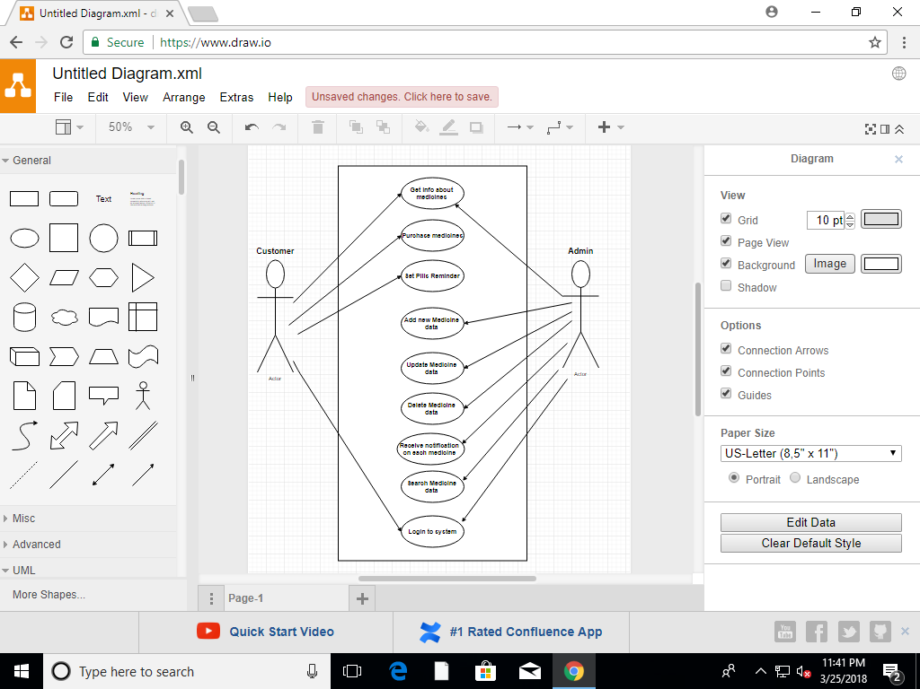

**Get info about medicines**

*Figure 2.3: Use-Case Diagram*

**Login to System**

## 2.4 ACTIVITY DIAGRAM

*Chapter 2: Analysis and Design*

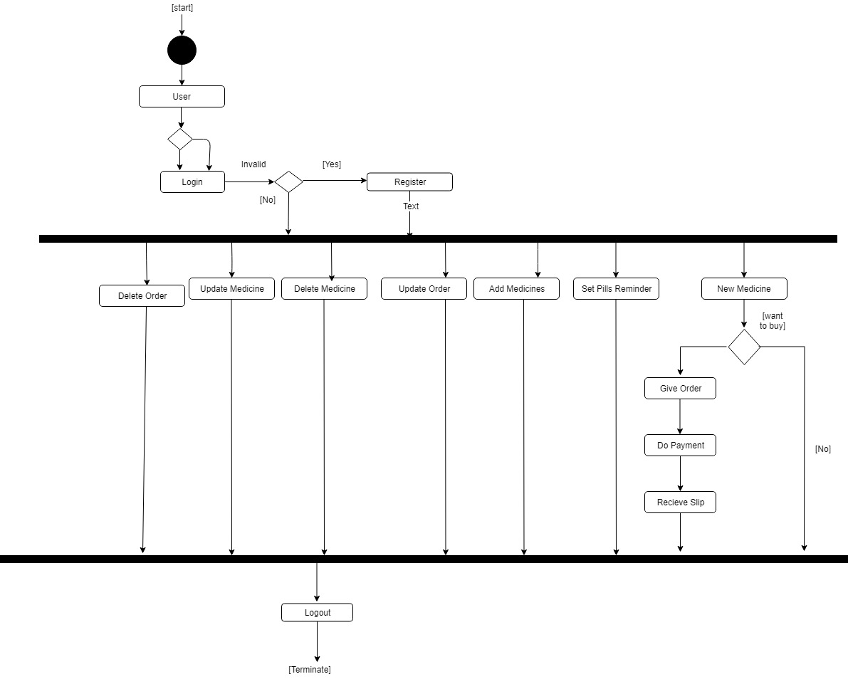Activity diagram walk through all the application activities step by step. The user have to login to the system. If the user is invalid then have to register themselve to the application and if the user is valid then they can perform all the functions. Th user can delete order, update medicine, delete medicine, update order, add medicines, set pills reminder. The user can add new medicine and if they wants to buy medicine then they will have to give order, do payment and receive slip. Otherwise can logout from the system.

*Figure 2.4: Activity Diagram*

## 2.5 DEPLOYMENT DIAGRAM

*Chapter 2: Analysis and Design*

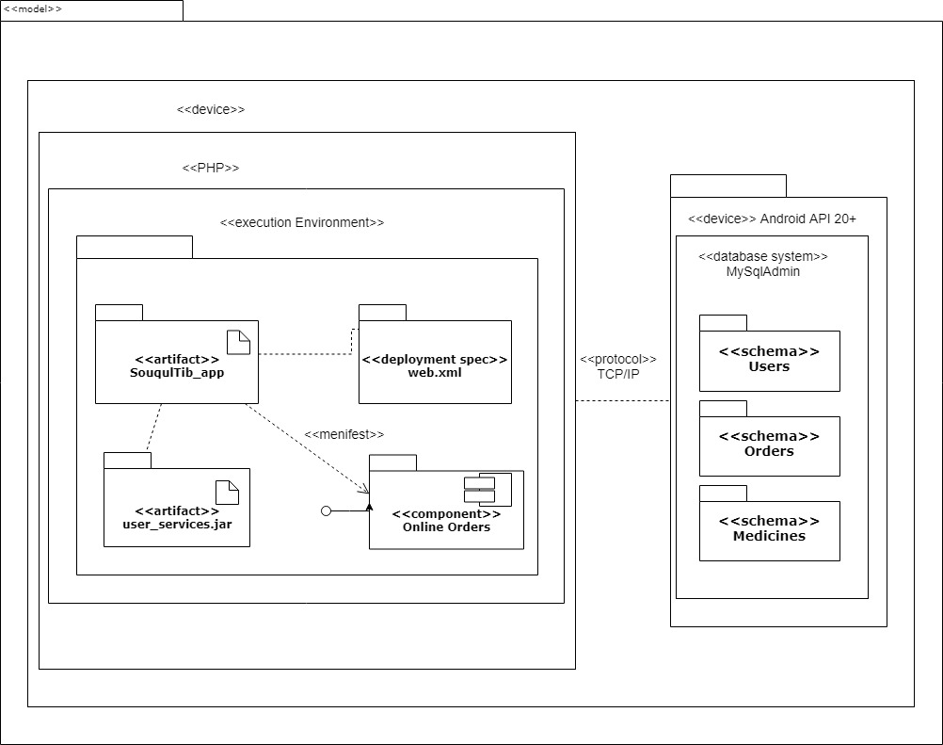Deployment diagram is a structure diagram and it shows the architecture of the system. In this the application execution environment is shown in which the artifact is Souq-ul-tib, the artifact has deployment spec “web.xml”, the artifact “userservices.jar” and component “online orders”. It is connected to the Android API device through the TCP/IP protocol. The database system consists of schema of users, schema of orders and schema of medicines.

Figure 2.5: Deployment Diagram

## 2.6 CLASS DIAGRAM

*Chapter 2: Analysis and Design*

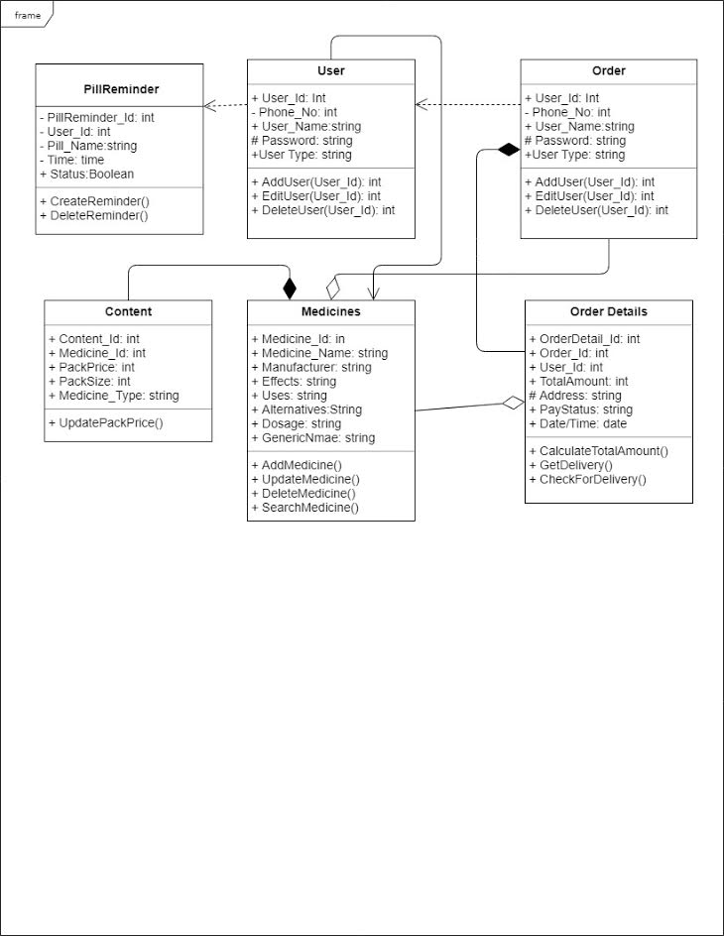Class Diagram is a static diagram that describes the structure of the system by showing the system’s classes and their operations, attributes and relationships between objects. The pill reminder contains pill Reminder-id, user-id, pill name, time, status. The user can create reminder and delete reminder. The user should provide their User-id, phone-no, user-name, password and user-type. The user can edit, add, and delete themselves. The admin user can enter all the necessary information like: medicine-id, medicine-name, manufacturer, affects, uses, alternatives, dosage, generic name and can add, update, search and delete medicine. The content has strong relationship with the medicine and contain: content-id, medicine-id, pack price, pack size and medicine-type and can update pack price. The user can place order by providing the admin with their user-id, phone-no, user name, password and user-type. The admin can add user, edit user and delete user. The order should have all the necessary order details like: orderdetail-id, order-id, user-id, total amount, address, pay status and date/time. After order details calculate total amount, getdelivery and checkfordelivery.

Figure 2.6: Class Diagram

**Chapter 3**

*Chapter 3: Tools and Technologies*

**TOOLS AND TECHNOLOGIES**

## 3.1 SOFTWARE

### 3.1.1 Microsoft Visual Studio 2015

From Microsoft, Microsoft Visual Studio is an [Integrated Development Environment](https://en.wikipedia.org/wiki/Integrated_development_environment) (IDE). Through this software we have created our admin panel by creating all the necessary pages for the admin to insert, update and delete records. It contains different forms like medicine, medicine-type, generic name and manufacturer. Each of these are divided into 3 categories insert, update and delete. Through this the user can add, update and delete medicines and all this will be saved into our SQL database.

### 3.1.2 Microsoft SQL Server Management Studio

The SQL server management studio database will maintain all the records of medicines and manage them. All the medicine record will be managed and retrieved through this database into our admin panel.

### 3.1.3 Asp.Net

ASP.NET is an [Open-source](https://en.wikipedia.org/wiki/Open_source) [server-side](https://en.wikipedia.org/wiki/Server-side_scripting) [web application framework](https://en.wikipedia.org/wiki/Web_application_framework) designed for web development to make [dynamic web app pages](https://en.wikipedia.org/wiki/Dynamic_web_page). It was developed by the [Microsoft](https://en.wikipedia.org/wiki/Microsoft) to allow [programmers](https://en.wikipedia.org/wiki/Programmer) to make dynamic web services, web sites and web application.

We have created our web services by using asp.net.

### 3.1.4 Android Studio

Android Studio is design specifically for Android developers. Android software development is the procedure by which new apps are shaped for the [Android operating system](https://en.wikipedia.org/wiki/Android_%28operating_system%29). Applications are usually developed in the Java programming language using the Android [software development kit](https://en.wikipedia.org/wiki/Software_development_kit) (SDK). The Android [software development kit](https://en.wikipedia.org/wiki/Software_development_kit) (SDK) includes a comprehensive set of development tools. These include a libraries, [debugger](https://en.wikipedia.org/wiki/Debugger), and a handset of [emulator](https://en.wikipedia.org/wiki/Emulator) based on [QEMU](https://en.wikipedia.org/wiki/QEMU), code, sample, documentation and tutorials.

Android studio is the main tool through which the application is created. The customer can place orders of the medicines through the app, get information, set pills reminder and benefit themselves with the OCR technology.

*Chapter 3: Tools and Technologies*

### 3.1.5 Web Services (Restful API)

REpresentational State Transfer (REST) is an architectural style that postulates constraints, such as the uniform interface, that if useful to a web service induces required properties, such as scalability, performance, and modifiability, which enable services to work best on the Web.

C**hapter 4**

*Chapter 4: User Interface Design*

**USER INTERFACE DESIGN**

## 4.1 Mobile Interface Design

### 4.1.1 Launcher Screen

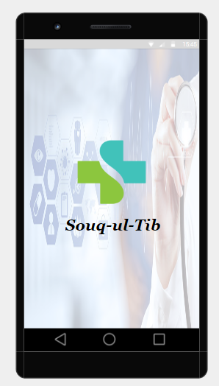The launcher screen is splash screen in this screen when the user see the application name and logo and after some time it automatically moves to the next screen.

Figure 4.1.a: Launcher Screen

After the main screen the next screen appear here are two option in which the user can select the login and register

**Register**: First the user have to registered them self to use this application

**Login**: If the user can registered, so they not need to register every time just login by entering phone number and password and use the Application.

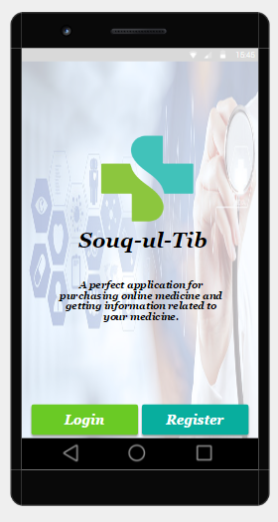

*Chapter 4: User Interface Design*

Figure 4.1.b: Main Screen

### 4.1.2 Login

In login activity user can login the application by entering phone number and password.

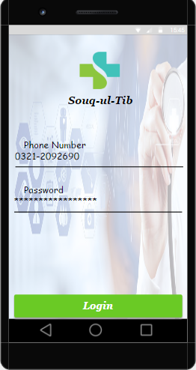

Figure 4.1.2: Login

### 4.1.3 Pills reminder

*Chapter 4: User Interface Design*

In Pills reminder feature the user can set the pills taken timing

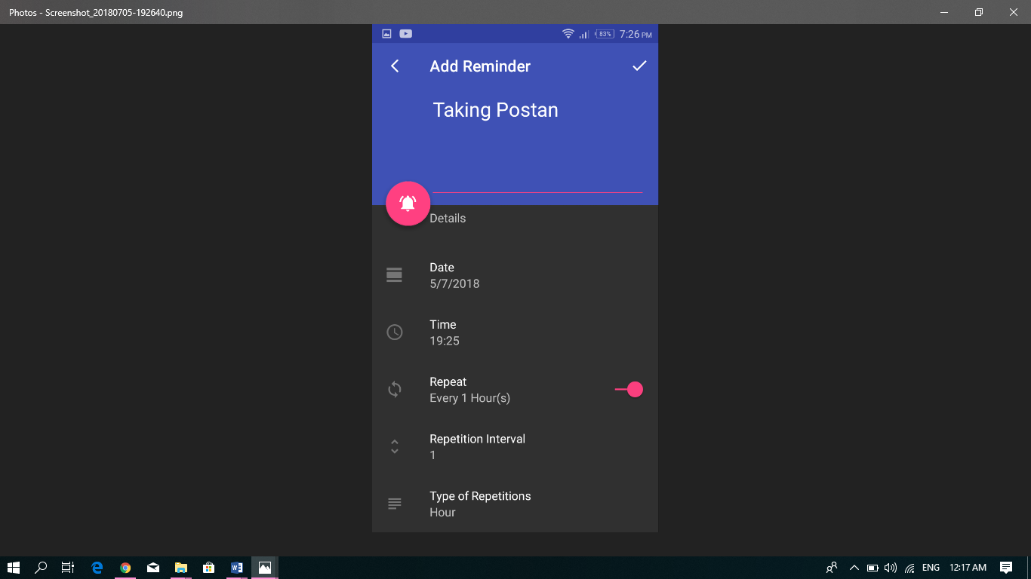

Figure 4.1.3: Pills Reminder 1

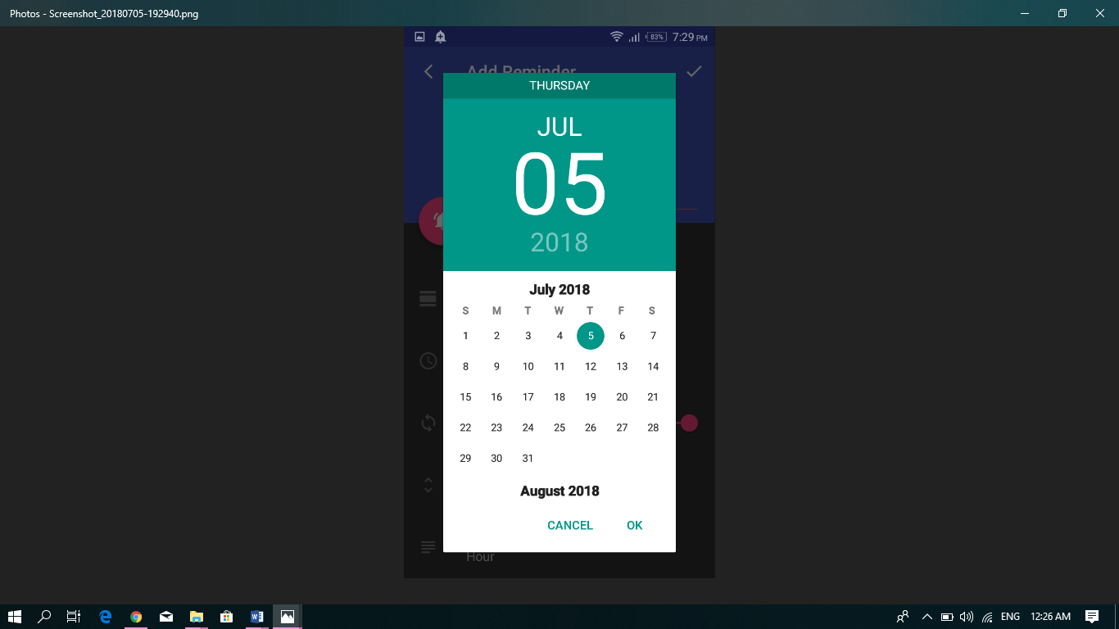

Figure 4.1.3: Pills Reminder 2

*Chapter 4: User Interface Design*

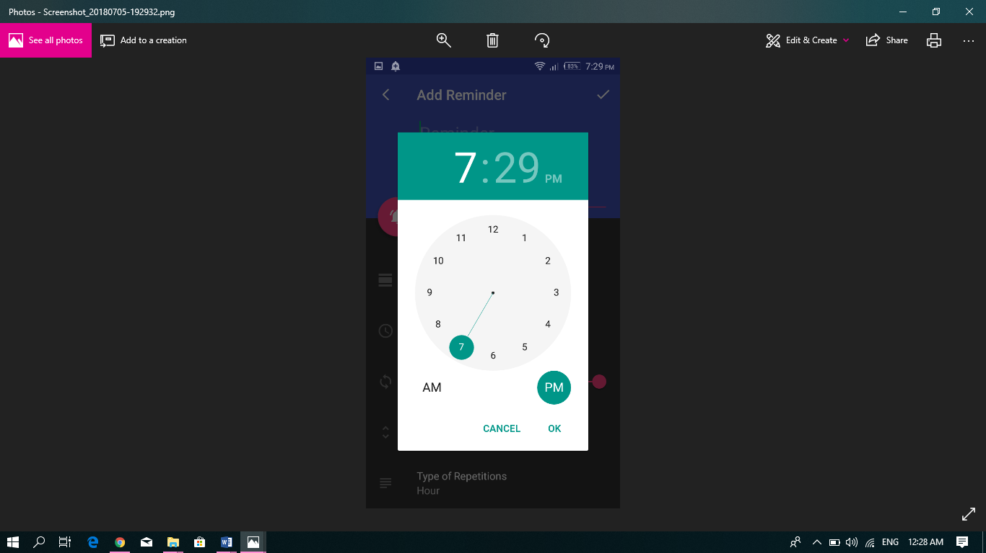

## 

Figure 4.1.3: Pills Reminder 3

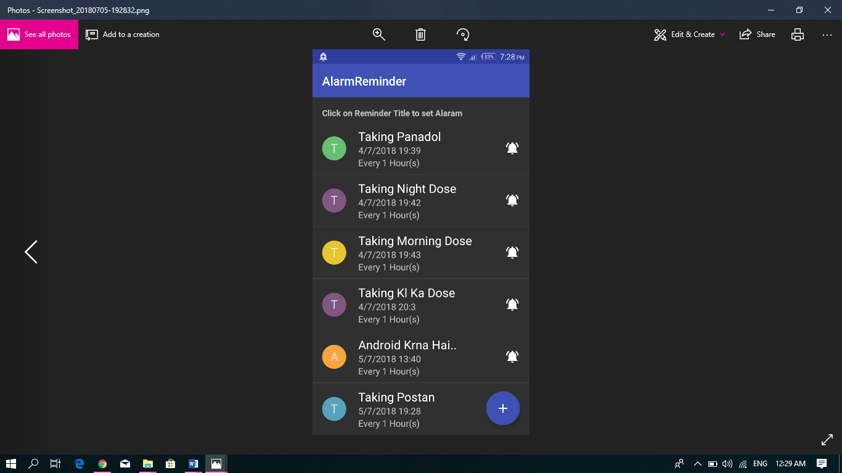

Figure 4.1.3: Pills Reminder 4

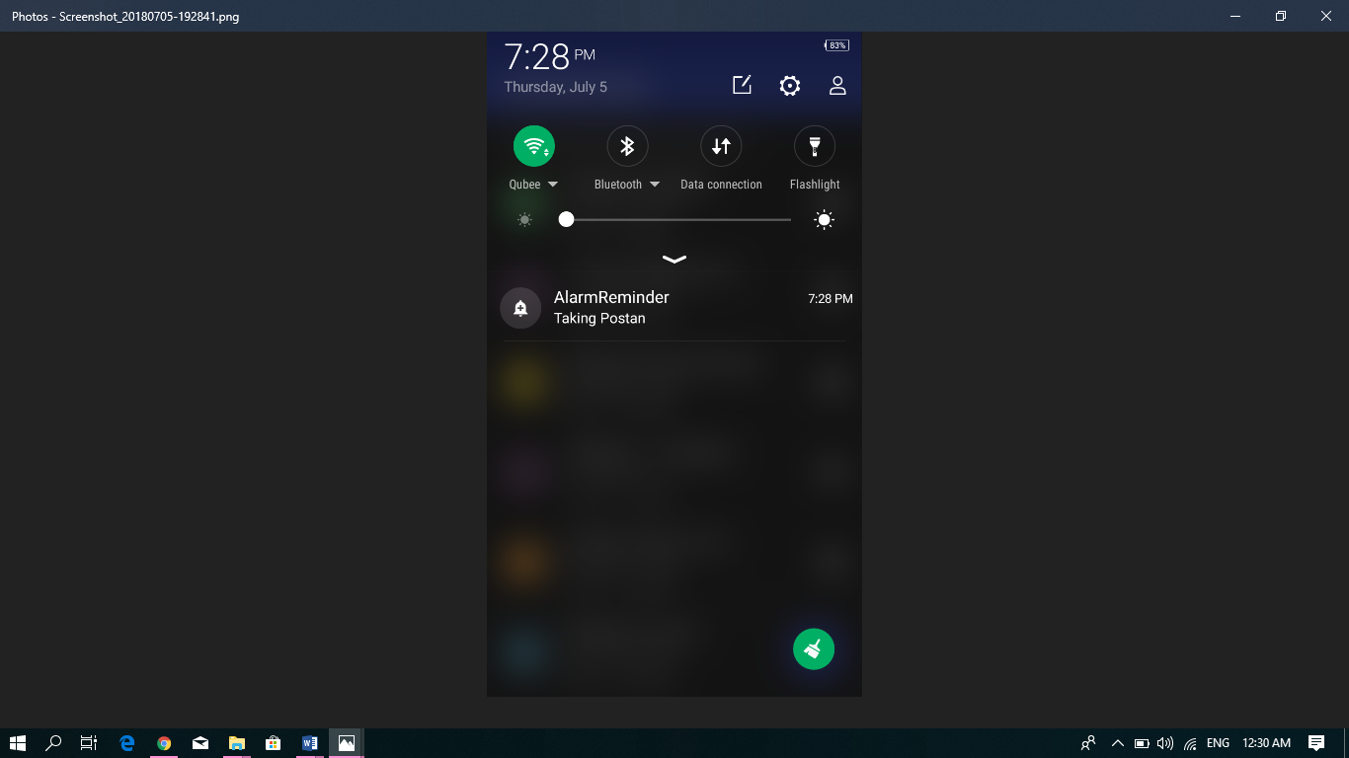

Figure 4.1.3: Pills Reminder 5

## 4.2 Hardware interface

*Chapter 4: User Interface Design*

There is no hardware interface our application is based on software.

## 4.3 Software interface

* GOOGLE MOBILE VISION API
* Android Studio
* Microsoft Visual Studio
* Sql Server
* Restful Services

# Chapter 5

*Chapter 5: Implementation*

# Implementation

## 5.1 DATABASE DESIGN

### 5.1.1 Entity

#### 5.1.1.1 User

User is an entity of our database which having an attributes **User_ID** as a primary key which having the registered user ID, Phone which having the phone numbers of the users, Name which stores the name of the users, **user_type** define who is user admin or the customer.

#### 5.1.1.2 Order

Order is an entity of our database having an attributes **order_ID** as a primary key which having order ID. **User_ID** having user’s Id, **Med_ID** having medicines Id, Price having price of the Medicines.

#### 5.1.1.3 Medicine

**Medicine** is an entity of our database which having an attribute **Med_ID** as a primary key which having medicines ID, **Med_Name** in which the Medicine name is stored, **Generic_name** define the generic name of medicine, **Effects** in which the small description of medicine effects, side effect is define, **Uses** in which also small description of the uses of medicine is given, **Manufacture** here we defined the medicine manufactured company, **Alternate** define the alternate names of medicines.

#### 5.1.1.4 Content

Content having an attribute **Med_ID** which having medicines ID, **Content_ID** as a primary key which having id of content, **Type** having the type of medicines like tablet, syrup, injection etc. **Price** having price of medicine.

#### 5.1.1.5 Order Detail

Order Detail having an attribute **orderdetail_ID** as a primary key which having an order detail ID, **Order_ID** having an order ID, **Address** having customer’s given address for delivering medicine.

#### 5.1.1.6 Pills Reminder

*Chapter 5: Implementation*

Pills reminder having an attribute like **user_ID** which can store the users ID**, Pills_ID** which can store the pills id**, Pills_Name** which can stored the names of pills**, Time** which can set the timing of pills taken**, Status** which can set the status that what notification can be given when pills reminder notification can appear .

## 5.2 WEB SEVICES

We make the following web services for our project:

### 5.2.1 Restful Services of Generic Name

A web service of generic name is developing for user’s perspective the admin can add or update and delete the generic name of medicine so the user can easily get medicine’s generic name. Web service to get all the information of a single medicine or to get all the medicines in the list, web service to update a medicines price in case of any discount offers.

### 5.2.2 Restful Services of Manufacture

A web service of manufacture is developing for the user’s perspective the admin can add or update and delete the medicine’s manufactured company so the user can easily know the company name of the medicine.

### 5.2.3 Restful Services of Medicine

A web service of medicine is to develop for the (admin and users) the admin can add, update or delete the medicine records. Web service to get all the information of a single medicine or to get all the medicines in the list, web service to update a medicines price in case of any discount offers or any new offer.

5.2.4 Restful Services of Medicine Type

A web services of medicine type is developing for the customer and admin side that the user can know the type of medicine such as injection, ointment, gel, tablets, syrup, capsules etc. before ordering the medicine.

### 5.2.5 Restful Services of User

A web service is developed for the user (app users, admin) which create a new authorized user. Also a web service is written to get all the data of the registered users in json or any specific user’s details, particularly the Read operation of the user is written for the admin perspective.

*Chapter 5: Implementation*

# Chapter 6

*Chapter 6: System Testing*

# System testing

The system testing can be done to verify that our system supports the verified features of our application or not.

## 6.1 Test plan

We can make test plans to verify all the functions and features are worked properly or any problem can occur. The test plans are as follow:

### 6.1.1 Mobile application testing

The main purpose of this test plan is to classify all the requirements which will be used during the testing. We generate a test plan since preparing it advantages us to think through the efforts needed to validate the acceptability of a software product. We generate a test plan for we want a document that describes the scope, objectives, approach and focus of the software testing effort. We generate the test plan for we want a chance to review the test plan with the project team. We create a test plan because it can and will benefit people outside the test group to understand the why and how of product validate.  This document will also advantage us to realize the requirements. We can test to verify that all the features of mobile application can work properly or not.

### 6.1.2 Test objective

The main objective of testing is to check the functionality of the project “Souq-ul-Tib” whether all of its module work accurately according to the specific requirements and all the requirement can be fulfill. The testing will be executed to check the test scripts identified the specific problems and bugs and to verify that all the objectives are fulfill.

6.2 Functional testing

The functional testing can be done in order to verify that our features of application and system can perform the valid functionalities or not. The functional testing are as follows6.2.1 Purpose

We would test the main functionalities of Souq-ul-Tib application which includes: Registered, Login, Medicine ordering, Pills reminder, Add to cart in order to done these testing is to verify that the following features of testing work properly.  
6.2.2 Testers

*Chapter 6: System Testing*

Testing can be done by the testing team. Testers are testing team.  
6.2.3 Method

The testing would be performing according to the functional script of the features.

6.3 System Testing

The system testing can be done to verify that the following features support the system or not. The system testing are as follow:

6.3.1 PURPOSE

The purpose of system testing is to verify that the developed application work properly, or the system is supported our application or not.

6.3.2 TESTERS

Testing can be done by the testing team. Testers are testing team.

6.3.3 METHOD

The testing would be performed according to the functional script of the features.

6.4 TEST CASE

|  |  |  |  |  |  |  |
| --- | --- | --- | --- | --- | --- | --- |
| **TestCaseID** | **TestCaseScenario** | **Test Steps** | **TestData** | **ExpectedResults** | **Actual Results** | **Pass/Fail** |
| TC01 | Check customer Login with valid Data | 1. Enter Userid | Userid=test | User should login into application | As expected | Pass |
| 2.Enter Password | Password=abc@ |
| 3.Click Submit Button |  |
| *Chapter 6: System Testing*  TC02 | Check customer login with invalid data | 1. Enter UserId | Userid=test | User should not login into application | As expected | Pass |
| 2.Enter Password | Password=ab |
| 3.Click Submit Button |  |
| TC03 | check payment method | 1.On cash |  |  |  |  |
| 1.By card | User’s bank account | Card have a balance | As expected | pass |

# APPENDIX A

*Appendix A*

# Glossary

|  |  |  |
| --- | --- | --- |
| **A.1** | **API** | Application program interface |
| **A.2** | **SDK** | Software development kit |
| **A.3** | **IDE** | Integrated development environment |
| **A.4** | **MY SQL** | My structured query language |

# Conclusion

*Conclusion*

In the FYP-1 the Admin panel from web site and pills reminder feature from the android application has been completed and in FYP-2 all the features of android application would be completed that are OCR, ordering and prescription upload.

.

# References

*References*

Satalkar, A. (2017, Dec 15). Dawaee.pk. Retrieved from https://www.dawaee.pk

Punjeeb, B. (2018, Jan 15). pakmedi.pk. Retrieved from https://www.pakmedi.pk